**From:** Advik Maniyar, Binghao Huang, Haowei Cao, Honghui Zheng

**Date:** 11/13/2024

**Course:** EN.601.490 (02) Introduction to Human-Computer Interaction

**Subject: iPad Formula Input Keyboard Design Report Part II**

**Section 1 – Introduction**

**Problem Statement:**

In today's digital learning landscape, iPads have become invaluable tools for students and educators alike due to their portability and versatility. However, despite their popularity, iPads fall short when it comes to efficiently inputting complex mathematical and scientific formulas. Existing formula input tools, such as those used by Wolfram Alpha or Symbolab, disrupt users’ workflow with frequent mode switching, cumbersome symbol searching, and imprecise cursor control. These issues create a steep learning curve and lead to a frustrating user experience, especially for users who require frequent and accurate formula input. As a result, many users prefer using laptops or even handwriting formulas on paper, which limits the effectiveness of iPads in academic and professional environments.

**Objective:**

The goal of this project is to design a more efficient and intuitive formula input tool that captures the ease and fluidity of handwriting on paper while leveraging the digital capabilities of iPads. By developing a streamlined and user-friendly formula input keyboard, we aim to enable users to input complex mathematical expressions with minimal interruptions. This tool is specifically designed to enhance the academic and educational experience, making iPads a viable option for disciplines requiring frequent formula input. Through innovative features such as precise cursor control, and an optimized layout, this tool seeks to address existing pain points and improve the overall user experience for students, educators, and professionals.

**Section 2 – High-Fidelity Prototype**

1. **Summary of Improvements from Part 1:**

In our usability study in Part 1, we identified several core issues that users faced when inputting complex mathematical formulas on iPads. Key pain points included a lack of precise cursor control, the frequent need to switch between input modes, and inefficient symbol searching, all of which disrupted workflow and hindered productivity. Users also found existing tools challenging to learn and navigate due to multi-layered menus and unintuitive interfaces.

Particularly noteworthy was our observation that the method of triple-clicking the integral button to input higher-order symbols was not intuitive for first-time users, significantly impacting workflow efficiency. This observation led us to implement a more user-friendly approach: a context menu triggered by long-pressing, which provides direct integral symbol selection. This change reduced the number of clicks required and better aligned with user expectations for quick access to complex symbols.

To address these issues, the high-fidelity prototype introduces several innovations. The navigation control (virtual joystick) allows users to precisely position the cursor within complex formulas, enabling seamless adjustments to superscripts, subscripts, and other mathematical structures. We enhanced this feature by implementing a selection mode activated through long-pressing the joystick, allowing users to rotate clockwise or counterclockwise to select and modify characters. This improvement directly addresses the precision issues users faced when attempting to edit formulas through screen tapping. This feature enhances accuracy and efficiency, minimizing the frustration associated with screen tapping for cursor placement. The symbol layout is optimized to display commonly used mathematical symbols directly, reducing the need for frequent mode switching and symbol searching. Additionally, shortcuts are included at the bottom of the interface to guide users in performing essential functions, such as adding superscripts or subscripts, further smoothing the user experience and reducing the learning curve.

The symbol layout has been optimized with a new collapsible system where commonly used mathematical symbols are displayed directly, while additional related symbols can be accessed through a long-press gesture. Users can then swipe horizontally to navigate through the expanded symbol options, effectively reducing the need for mode switching while maintaining access to all necessary symbols. This approach maintains interface simplicity while ensuring comprehensive symbol availability.

1. **Prototype Creation Process:**

The creation of the high-fidelity prototype was guided by the insights gained from Part 1’s usability study and employed a hybrid approach, combining Figma's prototyping capabilities with web-based technologies. For the for former, recognizing that users needed a fluid and efficient input process, we prioritized features that would streamline formula entry and minimize disruptions. Instead of relying on a multi-layered menu structure, which complicates symbol retrieval, we designed a simplified layout where essential symbols are immediately accessible. On the other hand, while Figma served as our primary tool for designing the UI elements and basic keyboard interactions, we recognized its limitations for implementing more complex interactions. Our Figma work focused on creating the visual design and prototyping basic interactions, including the "while pressing" and "click trigger" behaviors for the long-press symbol selection feature.

One significant challenge was achieving precise cursor control on a touch-based interface. Unlike a traditional keyboard, where arrow keys provide fine control, iPads require a different solution. To overcome this, we introduced the virtual joystick as a substitute for arrow keys, allowing users to navigate formulas with precision by holding and moving the joystick in specific directions. Another challenge was ensuring compatibility and ease of access, which led us to develop a web-based prototype rather than a Figma model. This approach allowed for broader accessibility across devices and did not limit the functionality to Figma’s interface constraints. Key technologies used in this web-based solution included HTML, CSS, and JavaScript, which enabled us to build an interactive, functional prototype that closely resembles the final product’s experience.

1. **Screenshots & Key Features:**

The high-fidelity prototype includes several key features designed to enhance user experience:

* 1. **Virtual Joystick:** Positioned on the left side, the joystick allows users to move the cursor precisely within formulas, adding superscripts, subscripts, and fractions with ease. This feature mimics the control of a physical keyboard’s arrow keys, providing flexibility akin to using a mouse.
  2. **Math Symbols Layout:** The symbol panel on the right side displays commonly used mathematical operators and symbols in a single layer, allowing users to quickly locate and input symbols without searching through multiple menus. This layout includes symbols like integrals, square roots, and Greek letters, which are frequently used in academic formulas.
  3. **Shortcuts:** Located below the symbols, the shortcuts provide guidance for essential operations, such as moving the cursor, adding superscripts and subscripts, and returning to the main text. These shortcuts serve as a quick reference for users, helping them become familiar with the interface more quickly.

Each feature is designed to streamline the formula input process, providing a more intuitive and efficient user experience. Below is a screenshot of the prototype, showcasing the virtual joystick, math symbols, and shortcuts in action.

**Section 3 – Participatory Design**

**Target Audience and Participant Selection:**

The target audience for this project includes students and professors who frequently work with complex mathematical or scientific formulas, particularly those in academic or educational settings. These users often encounter difficulties with traditional formula input tools and require a solution that improves efficiency and ease of use. To gather relevant insights, we selected a participant who closely resembles our target audience profile.

For this participatory design study, we chose a college student, similar to John’s persona, who is majoring in Applied Mathematics. The participant is 21 years old, highly experienced with mathematical software, and regularly engages in activities that require complex formula input, such as mathematical modeling competitions. This selection ensured that feedback would be relevant to both the needs and challenges faced by our primary user group.

**Activities and Methods:**

1. **Live Prototype Testing:** The participant interacted directly with the web-based prototype, allowing us to observe their navigation and usage patterns in real-time. This method provided insights into how intuitive the design was and highlighted any usability issues.
2. **Think-Aloud Protocol:** During the live testing, the participant was asked to verbalize their thoughts and impressions as they interacted with the prototype. This approach helped us understand their immediate reactions to various features, such as the virtual joystick and symbol layout.
3. **Mind Mapping Session:** After testing, we held a short mind mapping session to explore the participant’s preferences and gather ideas for potential improvements. This session helped identify features they valued most and areas where further enhancements could improve the tool's usability.

These methods were chosen to capture both qualitative and quantitative data, providing a comprehensive view of the participant's experience. By observing real-time interaction and recording verbal feedback, we gained deeper insights into user needs, preferences, and potential pain points.

**Design Iterations:**

The participatory design study included three iterations, each refined based on participant feedback:

1. **Iteration 1:**

**Objective:** The initial goal was to test the basic functionality and intuitiveness of the virtual joystick and symbol layout.

**Participant Feedback:** The participant found the joystick useful for cursor control but noted that some frequently used symbols, like square roots and integrals, were not immediately visible.

**Observations:** The participant expressed a need to access high-frequency symbols more easily without having to navigate multiple layers. They mentioned, “Having to search for square roots when I’m using them frequently slows me down.”

**Design Adjustment:** Based on this feedback, we rearranged the symbol layout to make high-frequency symbols more accessible. Square roots, integrals, and other commonly used symbols were placed in prominent positions on the main screen. This change aimed to reduce the time required to locate frequently used symbols, enhancing efficiency.

1. **Iteration 2:**

**Objective:** To test the newly arranged symbol layout and further improve cursor control precision through the joystick.

**Participant Feedback:** The participant appreciated the more accessible symbol layout, commenting, “It’s much easier to find the symbols I need now.” However, they noted that the joystick control felt “a bit too sensitive,” especially when trying to navigate superscripts and subscripts.

**Observations:** During testing, it was evident that minor adjustments to the cursor position could disrupt the flow when working with complex expressions involving superscripts and subscripts.

**Design Adjustment:** We introduced a sensitivity adjustment option for the joystick, allowing users finer control over cursor movement. This adjustment was particularly valuable for precise positioning within formulas, as it enabled users to control the cursor speed and sensitivity based on their task requirements.

1. **Iteration 3:**

**Objective:** To test the final arrangement of symbols and sensitivity adjustments in a more complex input scenario.

**Participant Feedback:** The participant found the updated joystick sensitivity useful for handling complex formulas but suggested an additional feature: a “favorites” section. They mentioned, “It would be helpful to have a place where I could store symbols I use frequently, especially during long sessions.”

**Observations:** This insight revealed a need for customizable options, particularly for users who often use specific symbols depending on their field or assignment type.

**Design Adjustment:** Although a complete “favorites” feature was beyond the scope of the current prototype, we added a placeholder section for frequently used symbols, labeled as “favorites.” This area would store recently used symbols in future iterations, reducing the time needed to search for them.

Each iteration helped evolve the design by addressing specific participant feedback. These incremental changes refined the tool’s usability, making it increasingly tailored to the needs of users who work extensively with mathematical formulas.

**Location and Setup:**

The participatory design sessions were conducted in a quiet study room on campus, providing a distraction-free environment that allowed the participant to focus entirely on interacting with the prototype. The room was chosen for its accessibility, as it offered sufficient space and a comfortable setup for both participant and facilitator.

To capture feedback effectively, we used note-taking and audio recordings to document the participant’s comments and suggestions during each session. This setup enabled us to thoroughly analyze each iteration and implement improvements based on precise observations.

This participatory design approach ensured that the final product reflected user-centered design principles, aligning closely with the needs and preferences of the target audience.

**Section 4 – Integration of Findings from Part 1 and Participatory Design:**

The final product was shaped by key insights gained from both the usability study in Part 1 and feedback gathered during the participatory design sessions in Part 2. In Part 1, we identified several pain points that guided the initial design decisions, including challenges with cursor control, symbol arrangement, and mode switching. To address these issues, we implemented a virtual joystick for precise cursor movement, an optimized symbol layout to reduce mode switching, and context-based shortcuts to streamline input processes. These features aimed to address the inefficiencies observed in existing formula input tools, creating a more intuitive and user-friendly experience.

The participatory design sessions further refined these features, allowing us to tailor the prototype to meet the specific needs of the target users. For instance, based on participant feedback, we made the following adjustments:

1. **Enhanced Symbol Layout:** The participant noted the importance of quick access to high-frequency symbols. In response, we rearranged the layout to make commonly used symbols, such as integrals and square roots, more prominent. This change minimized search time and improved workflow efficiency.
2. **Improved Cursor Control Sensitivity:** During testing, the participant suggested that finer cursor control would enhance usability when working with superscripts and subscripts. We responded by introducing a sensitivity adjustment to the virtual joystick, providing users with greater control and precision for navigating complex formulas.
3. **Placeholder for a Favorites Feature:** Based on the participant’s feedback in the final iteration, we added a placeholder for a “favorites” section that would allow users to save frequently used symbols for quick access. Although not fully implemented in this version, this feature was a direct response to user feedback and is intended for future development to enhance customization.

**Impact of Participatory Design Feedback:**

The participatory design feedback played a crucial role in fine-tuning the prototype, ensuring it addressed real user needs and preferences. Each iteration introduced new improvements based on observed interactions and participant comments. By involving the target user in the design process, we were able to create a tool that not only resolves the limitations identified in Part 1 but also incorporates features that directly reflect user input, such as the favorites section and enhanced cursor sensitivity.

These cumulative insights from both Part 1 and Part 2 culminated in a final product that is optimized for ease of use, efficiency, and precision in mathematical and scientific formula input. The result is a high-fidelity, user-centered prototype that bridges the gap between traditional formula input challenges on iPads and the specific needs of students and professionals in educational settings.

**Appendix A –Screenshots Hi-fi Prototyping and Mind Map**

Figure Mind Map of Participatory Design

Figure Prototype before Participatory Design

Figure Press and hold for more symbols (Participatory Design Iteration 1)

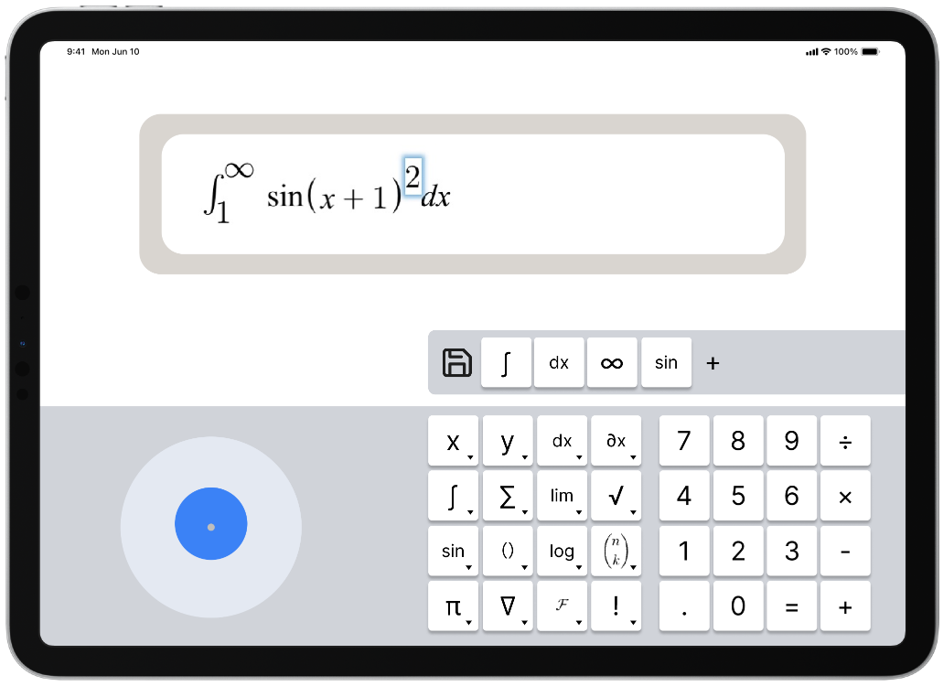

Figure Modify the symbol keyboard, and add a "favorites" list of symbols (Participatory Design Iteration 3)



Figure Final Hi-fi Prototype with full joystick funcionalities

**Appendix B - Participatory Design Note in Detailed Steps**

1. **Introduction:**

The session began with a brief introduction to explain the purpose of the design study, which was to improve the usability of the iPad formula input tool. I encouraged open communication to ensure the participant felt comfortable sharing feedback.

Participant Comments: The participant expressed excitement about participating, mentioning that they frequently used formula input tools and had encountered frustrations with existing options.

Outcome: This step created a collaborative atmosphere, setting a foundation for honest and constructive feedback throughout the session.

1. **Target Audience Exploration:**

Explanation: I explained that the target audience for this tool includes students and professors who work with complex mathematical and scientific formulas, with an emphasis on users who need intuitive and efficient formula input for academic tasks.

Participant Comments: The participant, a college student majoring in mathematics, noted that current tools often interrupt their workflow, leading them to rely on paper-based solutions instead. They expressed that a streamlined tool would make iPads more practical for their studies.

Outcome: This conversation confirmed that the participant’s experiences aligned with those of the target audience, validating the relevance of their feedback.

1. **Activity 1: Initial Design Evaluation and Idea Generation:**

Method: A mind mapping session was conducted to generate ideas and improvements for the symbol layout and joystick functionality. The participant brainstormed features they felt would enhance the tool's usability.

Participant Comments: The participant suggested placing frequently used symbols, like square roots and integrals, on the main screen to minimize searching. They also mentioned that navigating formulas would be more intuitive with finer cursor control.

Outcome: This feedback prompted us to prioritize high-frequency symbols in the layout for easier access. We also discussed potential sensitivity adjustments for the joystick to improve precision, laying the groundwork for specific design changes.

1. **Activity 2: Prototype Testing and Collaborative Redesign:**

Method: The participant engaged in live prototype testing, using the joystick to navigate complex formulas and providing real-time feedback on the symbol layout.

Participant Comments: While testing, the participant noted that the joystick felt “slightly too sensitive,” making it challenging to position the cursor accurately for superscripts and subscripts. They also recommended adding a “favorites” section to store commonly used symbols.

Outcome: In response, we adjusted the joystick’s sensitivity to enable finer control, which improved accuracy in complex expressions. We also added a placeholder for a favorites section, setting the stage for future customization options.

1. **Reflection and Discussion:**

Summary: After completing the activities, I summarized the changes made based on the participant's input and discussed further insights. The participant expressed appreciation for the improved layout and joystick sensitivity, noting that these adjustments made the tool more user-friendly.

Participant Comments: The participant reiterated the value of a favorites feature and stated that the improved cursor control significantly enhanced input speed and accuracy.

Outcome: This discussion validated the design adjustments and highlighted areas for potential future enhancements, such as a fully implemented favorites section.

1. **Feedback**:

Final Thoughts: I invited the participant to share any final feedback or suggestions for improvement. They expressed satisfaction with the progress made and were enthusiastic about using the tool for academic tasks once it was fully implemented.

Outcome: The positive feedback confirmed that the iterative changes had effectively addressed key user needs, moving the prototype closer to a practical, user-centered solution.

1. **Closing:**

Appreciation: I thanked the participant for their time and valuable input, emphasizing that their feedback had played a crucial role in shaping the tool.

Participant: This final step reinforced the collaborative nature of the design process and ensured the participant felt valued for their contributions.